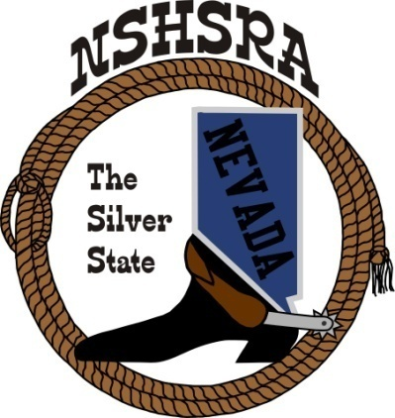
NEVADA STATE HIGH SCHOOL RODEO
MID WINTER MEETING

6:00 p.m. – Executive Board
9:00 a.m. Full Board
Mizpah Hotel
Tonopah, NV

Friday, January 31, 2025

The pledge of Allegiance was said.

The meeting was called to order at 6:03 p.m.

Roll call was taken and present were: Ron Unger, Bob Byrd, Shawn Silva, Jessica Lancaster, Nora Lee, Eddy Frehner and Jo Jo Webber (Olivia Process, proxy)

Absent were Chris Christian and Jo Jo Webber

Approval of previous minutes
Eddy made the motion to approve the previous minutes. Jessica 2nd and the motion passed.

HS National Director
Ron said in the shooting, they will be using an electronic scoring machine and the targets will be a little different material at Nationals. We as a state don’t have to change anything.
Need to make sure contestants are wearing boots with a 1” heel. Nora asked about having help be required to have the same. Ron said that he doesn’t think we need to worry about our volunteer help having to worry about that if they are helping in the arena. Dad’s that are helping their kids into the arena need to be aware of the rule.
Bull fighters and pick up man being using by the stock contractor cannot be under 18 years of age and cannot be a contestant. National insurance will not cover them.
Social media needs to be looked at differently. Cannot post anything inappropriate. Kids need to know that they could be disqualified.
In the breakaway, the string needs to be tied at the knot of the rope, not in the middle. String needs to be braided masonry string in bright colors. Rope cannot be looped around the horn.
If rule is not covered in the National rule book, we need to refer to the PRCA or WPRA rule books.
If a kid calls for a calf, calf breaks the barrier, but the neck rope is still on the calf, a kid can pull up and ask for a re-run.
In the cutting, there will be 4 judges and a monitor and there will be one long performance, not 2 a day.
He talked about the Horse Protection Act and we need to log onto the Western Justice website to sign the petition.
Nora asked about student event directors and whether they are mandatory. Ron says that’s a national rule. Discussion followed on how hard it is to get the kids to volunteer.

Jr. High National Director
Bob said he agreed with what Ron said. He said he learned a lot at the meetings. He said the stock for the jr. high finals will be good.

State Help - Arena Director’s, Judge’s, Flagger’s
It was discussed what judge/flaggers we wanted. The board agreed they wanted Greg back as he does a good job for us. Kathy asked who else they wanted. No one had anyone in particular, so she will send out bid request to Greg, Ben Anderson and some others she knows.
Shawn wants to ask Troy if he will do it again. The board agreed.
Nora said she would like to see more than 1 person on the Queen committee. Thinks the contest will run better and has been asked to check into this possibility. She asked for the Eobard’s support. She also said that the student board wants to be more involved.
Kathy said she though that Beth should be in this conversation as she is the current queen coordinator.
Bob asked about cutting/RCH judges. Shawn said TJ Shippy is working on those and will report at tomorrow’s meeting.

Treasurer position
Shawn says he said Jen Darrough has expressed interest in the position.

State Schedule
The board looked over last year’s schedule and thinks it worked pretty well last year. Olivia asked if they could take down the fence before the goats. Some of the horses were having trouble with the fence up. The board agreed.
A tractor driver was talked about. Dale suggested using Ramon who just retired and is looking for some things to do. He knows the ground and the equipment.
Kathy asked if they wanted her to send out bids for practices and jackpots. The board said yes. She will get those out.

Good of the Association
Shawn asked about having a pregnant girl compete at our rodeos and what our liability would be. He’s worried about possibly getting hurt and how our insurance will cover that. Kathy said she can reach out to our insurance lady to ask what their policy is.
Bob wanted to thank the board and feels everyone has the kids’ best interest at heart.

With nothing further, the meeting was adjourned at 7:14 p.m.

