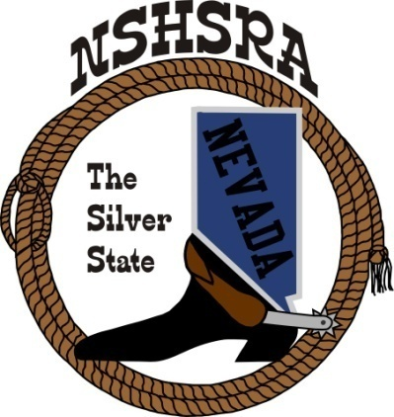
NEVADA STATE HIGH SCHOOL RODEO
FALL MEETING
Friday, August 14th at 4:00 pm – Executive Board
Friday, August 14th at 5:00 pm – Full Board
Eureka County Fairgrounds
Eureka, NV

AGENDA

Pledge of Allegiance

Call to order

Roll call

Minutes of previous meetings

State Finals Review: Do we need to change any times or dates for better performance? State arena director and flagger input for personnel.

New ground rules to adopt from the national office

Points system: Should the state be willing to consider changing to 7 best rodeos in our points as we have 13 rodeos this season.

State finals – locations, dates & duration starting in 2029

Cutting scoring ground rule, 60 is a score or have start as 61

Computer stock draw, no chips

Proposal to use eyes in all timed events including goats

Good of the Association

Adjournment

